Robot Framework (RIDE) Installation

There are some pre-requisite we need to install before going for the robot framework installation. These are mention below:

1. Installation of Python 2.7 Version of 32 bit ( As Python version higher than 2.7 will not support robot framework)
2. Set the path in environment variable for Python

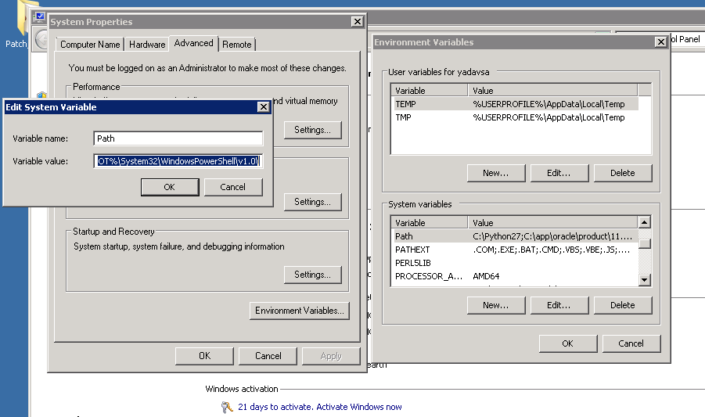

1. wxPython 32 bit Installation (make sure you should install the wxPython version same as the python version i.e. Python 2.7)
2. Installation of robotframework-ride-1.3 version (robotframework-ride-1.5 version will not support Python 2.7)

Please go through the screenshot below for importing the test suites in robot framework (ride):

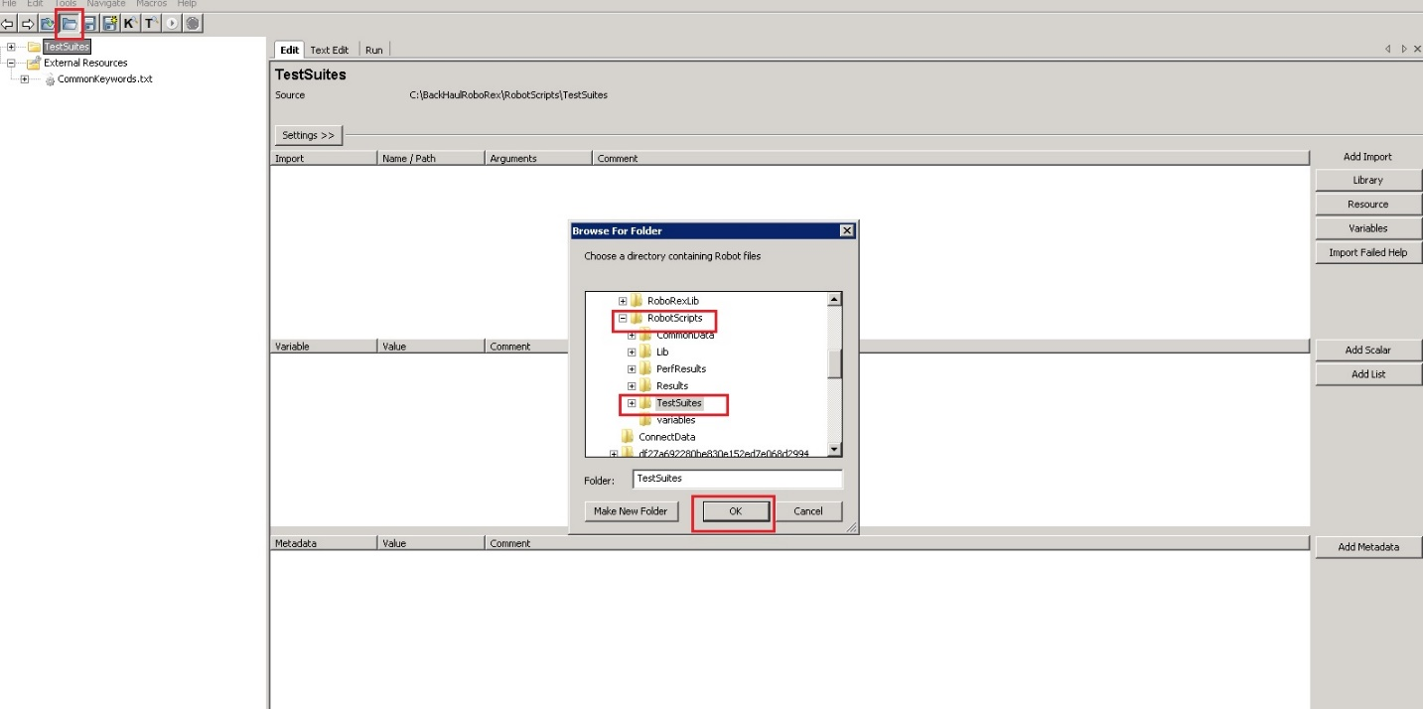

For Importing test suites , you have access the project under which open the RobotScripts folder and expand it further so that you can select TestSuites subfolder and click on Ok button.

After Importing the test suites , it will appear like this:

